**1)Explain about HFile**

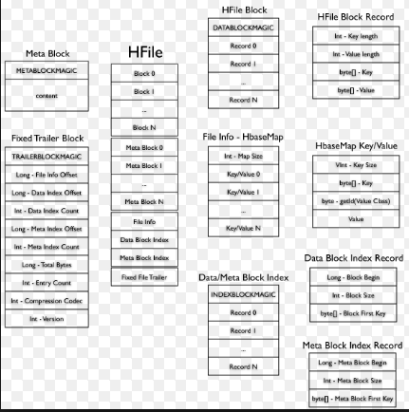

* File format for hbase.
* A file of sorted key/value pairs.
* Both keys and values are byte arrays.
* When the MemStore accumulates enough data, the entire sorted KeyValue set is written

to a new HFile in HDFS.

* This is a sequential write.It is very fast, as it avoids moving the disk drive head.

**2)Explain about HRegion Server**

* HRegionServer makes a set of HRegions available to clients.
* It checks in with the HMaster.
* There are many HRegionServers in a single HBase deployment.
* Region servers serve data for reads and writes.
* Regions are assigned to the Region Servers.
* A region server can serve about 1,000 regions.(which may belong to the same or different tables).
* It is a class in java

[java.lang.Object](http://docs.oracle.com/javase/6/docs/api/java/lang/Object.html?is-external=true) : org.apache.hadoop.hbase.regionserver.HRegionServer

* Region Server runs on an HDFS data node and has the following components:

WAL

BlockCache

MemStore

Hfiles

**3)Explain about HBase Meta Table**

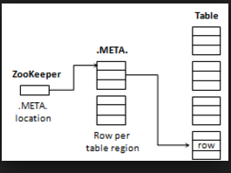

The .META. table keeps a list of all regions in the system. The .META. table structure is as follows:

Key:Region key of the format ([table],[region start key],[region id])

Values:info:regioninfo (serialized HRegionInfo instance for this region)

info:server (server:port of the RegionServer containing this region)

info:serverstartcode (start-time of the RegionServer process containing this region)

When a table is in the process of splitting two other columns will be created, info:splitA and info:splitB which represent the two daughter regions. The values for these columns are also serialized HRegionInfo instances. After the region has been split eventually this row will be deleted.

**4)Explain about Zookeeper**



HBase uses ZooKeeper as a distributed coordination service to maintain server state in the cluster.

Zookeeper maintains which servers are alive and available, and provides server failure notification.

ZooKeeper is a centralized service for maintaining configuration information, naming, providing distributed synchronization, and providing group services. All of these kinds of services are used in some form or another by distributed applications. Each time they are implemented there is a lot of work that goes into fixing the bugs and race conditions that are inevitable.

**5)How read and write operation is performed in HBase.**

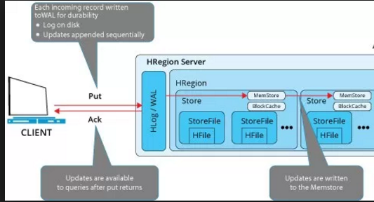

Read Operation:

A read request is sent to zookeeper from Hbase by the client.

* The zookeeper,gives the address for the META table.
* The process gets the region address of table from the META Table.
* From the specific HRegion, the process enters the BlockCache where data is present from previous read.
* If the table is found, the process returns to client with the data as result.
* If the table is not found, the process starts to search MemStore.
* If it is found, the process returns to client with the data as result.
* If the table is not found, the process moves forward in search of data within the HFile.
* The process takes required data from here and moves forward.
* The data is written in BlockCache, so that the next time, it can be instantly accessed by the client
* Finally the read process with required data will be returned to client along with acknowledgment.

Write Operation:

* When the client issues a Put request, the first step is to write the data to the write-ahead log, the WAL:
* Edits are appended to the end of the WAL file that is stored on disk.
* The WAL is used to recover not-yet-persisted data in case a server crashes.
* Once the data is written to the WAL, it is placed in the MemStore.
* Then, the put request acknowledgement returns to the client.